SPENDING PATTERN ANALYSIS OF GEN-Z STUDENTS



ATHARVA DADA HANDE

(Batch 2024-26 / PRN 24070243019)

Symbiosis Institute of Geoinformatics Symbiosis International (Deemed University) 5th Floor, Atur Centre, Gokhale Cross Road, Model Colony, Pune – 411016
Certificate

This is to certify that the project titled Spending pattern analysis of Gen-Z students is a Bonafide work done by Atharva Hande at Symbiosis Institute of Geoinformatics.

Internal Supervisor

Dr Vidya Patkar

Deputy Director at Symbiosis Institute of Geo-informatics

Table Of Content:

Acknowledgement 4

List of Tables 5

List of Figures 6

Introduction………………………………………………………………………………….8

Literature Review……………………………………………………………………………14

Tools and Techniques………………………………………………………………………..17

Methodology……………………………………………………………………………….....23

Result and Analysis…………………………………………………………………………..32

Discussion and Limitation……………………………………………………………………35

Conclusion and Future work………………………………………………………………..37

References……………………………………………………………………………………39

Acknowledgement:-
We would like to express our sincere gratitude to our internal supervisor Dr Vidya Patkar , for her valuable guidance for the entire tenure of our project, guiding me from the start of the object till today. Moreover, the feedbacks which always emphasized more on improvement rather than satisfaction has helped me do the thing that I’ve been doing since the past three months, The valuable insights from the supervisor has been of great importance, and gave the confidence to do what was needed and greatly enhanced the project, than what was expected from myself.
I would also like to thank the faculty members our institution Symbiosis Institute of Geo-informatics for providing us with the support to complete the project in the
desired way, also a big thanks to all of our respondents consisting of my friends, colleagues whose honest responses has helped me shape my project the way I intended got do, finally I greet my family for all the love and support which included constant support and motivation which helped me in the entire life-span of my project.

Atharva Dada Hande
MSc Data Science and Spatial Analytics
PRN:-24070243019
List Of Tables:-

Sr.No | Table Name
1 | Spending Influencers
2 | Literature Review Summary: India
3 | Literature Review Summary: Outside India
4 | Accuracy Table
5 | 5 Random Splits
6 | Other performance metrics for Random Forest Classifier

List of figures

SR.NO | Figure
1 | Flowchart of methodology
2 | Spender Type by age group
3 | Spender Type
4 | Confusion Matrix for Random Forest
5 | Confusion Matrix for Decision Tree
6 | Confusion Matrix for logistic regression
7 | Spender by Age Group
8 | Spender Type
9 | Spender Type

INTRODUCTION

Spending pattern of various generations has been studied to see the chase in their spending priorities, habits and to basically study what the current trait is among people of certain generations This paper will try to study the Gen-Z which is the most recent generation in power in todays date that have grown up with technology being in the forefront and evolving with them, So basically here we study the group people who were born from the year 2000 to 2007, that is the people who age between 18-25 years old, who have just entered the working age and will lead this working age group of our country for the next 20 years at least, and hence knowing how they prefer to spend money is very important, because that is the backbone of how the country’s major population will think when it comes to money, spendings and savings as such, they almost consist of 15% of the current population of the country and hence their approach towards spending is one of the most emerging topics of study that amuses many researchers in our country seeing the dynamic scenario the generation is going through saying this, we could point to Digital payments, E-commerce, Increase in technology and the rise in digital payments from the past 10 years which has also changed the mindset of people when it comes to spendings, savings with very unequal growth in every distinct persons financial attitude. According to Bhatia and Shete(2021) UPI transactions have grown at quite a high number if we consider the past 10 years and is at an all time high.

Problem Statement
What old or prior studies who have worked on this topic have done is they’ve identified the influence of various factors on Gen-Z and their spending which consisted of few variables like

Table 1.1:- Spending Influencers

Digital Payments | Rise of google pay, phone pe, Upi payment apps
Peer influence | Uneven income shows rise in peer influence
Financial Literacy | Spending if it is a need and not a want most number of times
Online Shopping | Rise in online shopping has shaped people’s spending to an extent

Furthermore, the aim of the project will be to study the evolution of spending in the Gen-Z, and to identify the most probable attitude in individuals regarding their spending preferences, money spent

on entertainment, also eying their saving habits closely which also tell us about the financial attitude
while going hand in hand with increase in technology and various more spending options what the millennials had.
while going hand in hand with increase in technology with what the millennials had

Aim of our study
Try to expand on previous researches done, and categorising them with respect to their spendings using a self made questionnaire that will contain questions regarding personal data, financial attitude, peer influence, saving habits etc. Also testing various machine learning models and train them using train_test_split and compare the models (Logistic regression, Decision tree, Random forest) to analyse who will give the best accuracy which will also answer our problem statement how to successfully categorise the Gen-Z into various spending types based on their spending preferences

2) LITERATURE REVIEW
GEN-Z students and their financial evolution is an area of interest for many researchers across the globe, especially in India due to the hefty population the country has, and almost 15% of the people between the age group of 18-25, that is roughly around 10 crore people. As of the game of GEN-Z students their spending pattern has influenced a lot due to the increase in technology, E- shopping, Digital Payments. This literature review will focus mostly on the spending patterns of students and what factors influence the spending of people. According to Mishra and Rajora(2018), As cited by (DR.Bhatia, DR .Shete,2021) one such study was done in Mumbai basis a questionnaire of 48 students to understand the digital payments structure or system among youths, also a latest study done and cited in the same paper by Kumar, Choudhary, Kar, Bansal and Mishra (2022) examined that UPI peer to peer payments are at an all time high, predominantly due to the user friendly interfaces that UPI apps have to offer, which in turn increases engagement of visitors and usage of UPI for smallest of the payments

Adding more depth to our topic further understanding financial literacy among the GEN-Z and millennials is also an important area of study because a lot has changed like the job market, the mode of payments, e-commerce to a large extent and the interference of social media in the changing style and the way an individual thinks about his or her lifestyle, According to (Jainisha,Pandya, 2023) in she has stated that millennials being born from 1980 to the late 1990’s they have emerged as the generation who has closely seen the rise of internet, emerge of mobile phones, social media and E-Commerce they also were also known as the most sustainable generation who have seen or their life has been constantly changing with constant evolution in technologies market and also incidents like 9/11 attacks, Great Recession of 2008 this generation has always been in evolution, GEN-Z on the other hand are the generation born from the late 90’s to the early 2010 they have always been in contact with technology as they were born for using technology, unlike the millennial where they felt that technology was an luxury in those days especially in India, the GEN-Z is a generation of people who grew up as technology being the forefront of their lives like in simple words we can absolutely state that it has now become a necessity than a luxury.
Few variables in the study include terms like:

FINANCIAL ATTITUDE: Which basically consists of ones approach towards spending, how and with what mindset one tends to spend money, save money, his aim towards achieving his or her personal financial goals and is certainly considered as a hidden soft skill in today’s individuals FINANCIAL AWARENESS: This refers to the personal understanding of an individual like to what extent should he or her spend in order to achieve sustainability in the long run, like for example: IF we consider a pay of Rs 50000 per month to an individual, he cant take a car or an luxury item which costs RS 30000 per month as an instalment, this is considered to be a lapse in judgement and financial awareness plays a crucial role in blocking such financial lapses
FINANCIAL INFLUENCE: This is basically a contribution of external factors to ones way of living or understanding the concept of finance, like the new generation of iPhones are launched every year in the month of October, however the advertising of such brands is so eye catching and impactful that one tends to pay close attention to the product which is good for company’s area of interest another such factor might be peer-to-peer influence when some individual possesses the
same product the urge to own one of your own increases and hence financial influence plays a role with in the form of lifestyle influence, where both the above factors like financial attitude, financial awareness has a great role to play to overcome the impact of financial influence. When we talk about the GEN-Z the most influential thing in their lifetime was the “COVID-19” pandemic like for millennials it was the “2008 Global Financial Crisis”
Now if we look at the situation before the pandemic we were the shop from the store type of consumers where we used to buy things, particularly the daily household things from our local shopkeeper or shop vendors, but due to covid , due to the social distancing factor we preferred shopping from our households and not risking going out thats where I feel apps like blink-it tomato increased its reach, Online sales increased as mentioned by Arundhati Ramesh1 , Srishti Gulaty2 , Srushti Sarwate3(2023) digital retail sales grew from $38 billion from 2020 to over $83 billion in the year 2022, and globally the percent increased. From 16% to 27%, So the pandemic also was a critical factor in GEN-Z spending pattern as being the newest generation of people existing at that moment they were more prone to change than any other generation linked to the pandemic After the situation was stable and the world was coming back to normal children were back in the school, corporate jobs were resumed, stores were wide open till late night again the pandemic still gave us a big shift in how we lived our lives with the increase of online shopping which comprised of the smallest of small things to the bigger things available on the web, which not only changed the shopping ritual but also brought a change in the payment procedure with UPI’s being at the forefront since, also the pandemic increased or gave a hype to the use of social media with Apps like TIK-TOK then which is not in existence in the Indian market now, also the evolution of Instagram reels came into existence after the pandemic which was considered as a platform similar to tik-tok, which also influenced the lowest section of the society to be using Instagram and hence influence other people to adopt a certain lifestyle and change shopping behaviour of particular person and which can fall under financial influence or digital influence.

Offline to online shifts:- Convenience stands as the best factor that influences customer engagement in India with digital chatbots, online reviews, online ratings people tend to be more attentive on such things as this clearly replicates the authenticity of the product and also authenticity of the website, particularly in India we still mostly follow the traditional form of shopping but the confidence that people have shown on such online platforms were seeing a change, according to the study done by Harshal Dev(2024) the responses of 276 people were taken into consideration and
found out that 75% people were of the opinion or were prone more to spend on E-commerce rather than the traditional commerce platforms, where one such noticeable thing was the deduction of the guilt factor in individuals while paying online than paying via liquid money, such practises increased more after the pandemic as everything was cashless and hence UPI rised with resulting rise in the money spent and also local vendors going online, Rickshaw or Taxi drivers using UPI to their convenience . One more aspect of the study could be gender, which also plays an important role in our analysis as spending patterns could be differentiated according to gender. So,according to IIM(AHMEDABAD)(2024) it was found that males generally have a m ore regressive spending habit than women on a per transaction scale basis as males are observed to spend on an average of 36% more as compared to women per online transaction, like we obviously know and have observed that women spend less and still have a higher purchasing frequency or quantity. It’s observed that men tend to spend on more sustainability rather than variety, so men usually tend to spend more inspite of having less to offer whereas women tend to spend more on quantity ask variety.

Table 2.1: Literature review summary Scope:- India
Sr.No | Paper Name | Summary
1. | USAGE OF UPI TRANSACTIONS AND ITS CHALLENGES -A STUDY OF GENZ AND MILLENNIALS | The study focuses on two generations and their adoptions with digital payment that is the millennial born between (1981-1996) and the genz (1997-2012) who have grown up in a completely different world as such who also contribute to nearly 60% of the country’s population.
2. | A STUDY ON DIGITAL PAYMENT SYSTEM WITH SPECIALREFERENCE TOYOUTH | The study focused on collecting responses using a questionnaire based ON adoption and the challenges faced by them from 48 respondents as such and analysed with basic statistical tools.4
3. | THE GROWTH | Here the authors emphasise on peer payments

 | TRAJECTORY OF UPI BASED MOBILE PAYMENTS IN INDIA | sending and recieving money from individuals that is even the smallest of the smallest payments using UPI Apps like phone- pe google-pay where it was seen that this attracted the spenders to spend more or spend frequently using these apps, no matter the amount involved.
4. | A STUDY ON FINANCIAL LITERACY AMONG MILLENNIALS  & GEN-Z | Key variables like financial awareness, financial influence, financial knowledge , Financial behaviour were studied with respect to the Millennials and gen-z as such
5. | THE transformation of digital innovative services in retail trade due to the covid- 19 pandemic | Here this talks about the way businesses should adopt to the digital lifestyle and manage their sales effectively, which helps in expanding their supply chin to a more broader extent, while the pandemic put more emphasis on peer to peer supply of goods product it shows essential use of digitisation of their supply of goods.
6. | From case to cashless: UPI’S Impact on sending behaviour among Indian users and prototyping financially responsible  interfaces | This again shows the impact of digital payments and how it shapes the financial experience of end users at an indiavidual level with 75% increase in spendings, only 9% decrease and 95.2% people found UPI payments more convenient
7. | Digital Payment Patterns in India | A Cross- Sectional Study of Credit Cards, Debit Cards, and Unified Payments Interface (UPI) Trends: The study focused on the changing payment traits undergone within 20 months that is Jan’23 to Aug’24 which tries to cover a short term shifts between credit  card debit card and UPI payments using time series

analysis.

Table 2.2:
Scope:- Outside India Spending Patterns

Sr.No | Paper Name | Summary
1. | Buy Now, Pay Later: Assessing the Financial and Behavioral Implications for Gen-Z Consumers in the USA | The purpose of the study was to study the financial behaviour of the Gen-Z in the USA for this study due to the increasing behaviour of the buy now pay later method through online platforms with the amount of debt almost increased 3X in the financial year 2021- 22, where survey was done through online platforms that consisted of 150 people from different demographic background
2. | Generation Z and Financial Literacy in Japan: A Preliminary Discourse on Attitudes, Behavior, and Outlook | Here financial literacy has been treated among various Gen-Z personalities in two countries being Japan and US and it has shown explicit behaviour in the Gen-Z with their spending patterns being more towards the impulsive side of things.
3. | Gen-Z Shopping: Seperating myth from reality | The case study reflected on the financial traits go the Gen-Z with the number they have their importance to the society and covers all the variables that we’ve taken for our study like the covid 19, Financial awareness, digital marketing  and has stated that there is no fix algorithm or

shopping rule as such that perfectly defines the Gen-Z.

- Tools and Techniques used:-

Tools
- Google Forms:- Basically we wanted to collect primary data through our own scope that is the people from the age 18-25 that are in our own vicinity and collect responses from them regarding their spending preferences, they were tested with a total of 17 question from our questionnaire which included various questions like personal details question regarding financial stability and savings as a habit, which was all collected from a total of 254 respondents and then later carried forward for analysis.
- Google sheets:- The data collected from our scale of 254 respondents was stored in google storer that is in the google sheets which was later exported to CSV, so that it could be imported in our project through python and can be ready for analysis.
- Jupyter Notebook:- Default platform that w as preferred to carry out our python program, where we did all the necessary stuff for our project to be completed, and later fetch results as model accuracy and the model successfully predicting our spender into the categories that we’ve mentioned.

3.1.3 Python tools
- Num-py&pandas:- that was used for fetching data using pd.read_csv, creating data frames data manipulation, data cleaning etc.
- Matplotlib&seaborn:- This was used to plot the results that we’ve got from our analysis I.e we can say it was used to showcase the types of spenders with numbers clearly helping the non- computer science based audience with clear interpretation of results.
- Sci-kit learn and job lib:- Machine learning was done with the help of sci-kit learn where we trained and tested the data with a split of 80-20 that is 80% training data and 20% testing data, used to create a model that predicts spender types flawlessly with logistic Regression, Decision tree classifier and Random forest classifier. Joblib was later used to save the trained and tested model and later use it for dynamic predictions.

Techniques

- Survey method :- Data was collected using survey that was conducted using google forms and linked was shared through social media platforms or given personally to fill our questionnaire that successfully reached and was completed by 254 respondents.
Data preprocessing:- Making the data available and ready for analysis is what data preprocessing actually means in this we’ve completed many tasks before reaching our final outcome.
  - Handling missing values:- Cleaning the dataset and ensuring no null values exist in our dataset
for clean machine learning tasks.
  - Label encoding:- Assigning a number for each option like it has in the google form for categorical ML compilation as machine learning is quite entitled or build to handle only numeric data.
  - Scoring system:- Our options also consisted of mixed approaches one such thing was “I think for a while but often end up buying it”, this shows a balanced approach where the respondent wants to buy it but also has a look about his or her expenses so he also thinks for a while these questions are need to be given points as it has a mixed approach containing two spender types. Similarly we have assigned scores to all the options from our gun questions (Q6,Q12,Q13).
- Machine learning models:- We’ve used three machine learning models namely Logistic Regression, Decision Tree Classifier, Random Forest Classifier where all the models gave accuracies like (69%,95%,97%) respectively and hence the random forest was termed as our most accurate performing model.
- Evolution metrics:- With accuracy being our most dominant metrics we also had other metrics Precision, Recall, F1 score and confusion matrix as such
- Cross Validation using random seeds:- Due to the high accuracy we also checked random forest for overfitting where it showed us that the model even after 5 random splits gave us accuracy close to 95% everytime and once even more than 95% which was a good indication of great model performance.

RESEARCH GAPS:-

  - Many studies have worked towards showing the influence of diverse things on the GEN-Z and have found out various influential factors that has an effect on the spendings.
  - Social media influence, peer pressure, effect of the pandemic, financial literacy and awareness are the major influential things that majorly affect the spendings.
  - No existing research showcases how and to what extent does these factors matter to every individual at a distinct level.
  - Overall no paper showed the spending pattern of students in a categorical way that is no student was categorised based on their behavioural spending.

3)METHODOLOGY

Primary data collection method needs to be adopted for our research, as we analyse the spending patterns of the GEN-Z. A questionnaire containing questions regarding lifestyle & spending preferences, Financial Literacy will be created and shared keeping in mind our objective of collecting data from the GEN-Z by which we our more closer to our basic objective of analysing the influence of several factors upon GEN-Z and their spending preferences. Majorly the study will
contain people from the age group of 18-25 that is the people who were predominantly born from the year 2000 to 2007. The sample size adopted will majorly be sent to students through google form links through various platforms like WhatsApp, Linked-in, Social Media as we aim to collect the responses of at least 500 students so that we can have a decent number to research and conduct our study on, so that we can identify the spending patterns of people effectively.
Also we will try to gradually increase our network by trying to expand our questionnaire reach from our network to our mutuals and also their mutuals so it will circulate in a chain and only and only then we would be precise to analyse the spending pattern as each person replicates different households and their spending pattern, especially in a country like India or coming to a even closer scope to a typical maharashtrian household as spending pattern changes with each individual, their distinct lifestyle, their financial comfort etc. Like for example if we compare two students one from the more Private universities like Symbiosis and the other one from a minute village who has been admitted to the College Of Engineering Pune and has beens selected on merit basis. So, we can conclude that spending typically differs here, also when we talk about the age 18-25 many people have finished their academics and even have started working as IT freshers or some may even have adopted their family business so on a whole, spending of people can also differ in such circumstances or scenarios. If we talk about the general spending of a person at this age generally the spending tends to be more similar to that of his/her parents keeping outside factors like peer pressure Social media Influence etc.
After data collection is done, trying to implement our the data is the next most important thing, here we will try to predict classification models and then categorize them into:
Impulsive spender
Balanced spender

Planner/Saver

Frugal
Where generally all of them can be categorised using their responses from the questionnaire, as questions are framed in order to recognise the influence, the pattern of spending a man adopts while spending money. Here we our using multi class classification where each of our respondents are classified with respect to the choices made. We will be using the specific algorithm as only one category will be assigned to every respondent. Our project mainly consists of categorical data being analysed so for this, we will be using label encoding to ensure linearity between the model and input features.
Impulsive Spender:- These are spenders who prioritise their wants more than their needs, for example if someone has a bike which has ridden for only 5000 kms but someone from his peer group or friends buys a latest version of the same bike these impulsive spenders tries to replicate people, or easily gets influenced so they try to do the same thing as others.

Balanced Spender:- These are the spenders who basically keeps a check on their spendings and savings, with moderate peer influence like he or she will also want to buy the intended thing but unlike impulsive spenders they will have a big check on resources and will only try to buy things if it doesn’t disturb their savings and spendings quota
Planner/Saver:- Very similar to balanced spender, but here the only difference is balanced spender will spend on wants if the penny is affordable, while planners/savers prioritise savings first than buying things, they intend to save money for the long run.
Frugal spender:- These are the spenders who can be considered as spenders who live a very minimal lifestyle, not influenced a lot from peers or influential things going on in the ongoing market they are unbothered and are mostly addressed as “MISER”.

Though our questionnaire consisted of 17 questions but our analysis was only done with respect to only 3 questions from the questionnaire

Q6: When buying something you want (not need) which statement describes you the best? Q12: Which of these best describes your approach to saving?
Q13: Imagine you see a new phone model launched which statement describes you the best(Even if you’re not spending your own money but rely on your parents for money answer as per your convenience)?

All these questions works towards answering all the variables needed for our study and tests all the respondents in the same manner trying to solve the question of how exactly can we categorise the Gen-Z spenders with respect to their spending habits .

Encoding:
Q6: I buy it immediately without thinking much:0, I think for a while, but mostly end up buying:1,
I wait and save up for it before buying:2,

I often decide not to buy it at all:3
Q12: I save systematically as a priority:1, I save whatever is left after spending:1,
I rarely think about saving:2,I don’t save, I prefer spending in the present:3 Q13: I will buy it as soon as possible:0,
I will wait for the price to drop or offers:1
,I will save up over months to buy it:2,
I don’t plan to buy it as it isn’t necessary:3

Responses for the selected questions that is Q6,Q12,Q13 was encoded using label encoding for machine learning to work on top of this and predict results, machine learning cant work on text data to requires numerical data so it was important to covert these options into numeric labels which would be understood by the train_test_split and act as features for the training and testing part

Next thing is how we will use the data collected to our interest so, data will be split into a standard 80/20 ratio. That is 80% of the data gathered will be training data while 20% will be usedfor predicting the output. We will include extra labels to our dataset from the 4 categories we intend to split them in. The categorisation would be done by performing a scoring ,matrix using python where depending on the respondents choice of answers scores will be considered under each falling category and hence it will be just a matter of calculating what score an individual gets and will fall under which category all will be done on the python programming language in the

Jupyter environment. Classification is the task in hand that we will attempt to perform using the classifier techniques like Random forest classifier due to its high accuracy, and the strength to handle categorical data better than decision trees or logistic regression for that matter. The 80% training dataset would allow the model to learn from your data at hand, it will learn patterns from the data where input features like the options chosen by the respondent and the output spender type would be the learning curve, like if people have chosen this as their answer this is the spender type they’ll be according to the data and current scenario.
Also we will go with it as random forest is an ensemble algorithm that can be used for both classification and regression, with very less chances of error maintaining a good accuracy rate. Also, as previous researches have found out that random forest being less prone to overfitting or under-fitting due to its multiple decision tree structure can prove to be a very good choice for our project, Additionally, a comparative analysis among the three algorithms I.e the random forest
should also be shown as it then shows the difference in accuracy in all the algorithms and will also conclude which can be the best suited one.
Our predictions will be examined or treated by metrics such as
- Overall Accuracy: Percentage of correct predictions
- Precision, Recall, F1 score per class :Integrates model performance for each spender type individually
- Confusion Matrix: to understand the misclassifications that have been made and understand the overlapping between categories
The analysis as previously discussed would be conducted on the Jupyter notebook environment using the python programming language, using libraries such as pandas, Sci-kit learn,
Mat-plot-lib for data manipulation, encoding-decoding and the machine learning prediction part. Lastly, if we have an overall view of things this methodological framework will enhance the study being made on the GEN-Z as this is the hot topic currently and also as we move forward in the days to come. So our attempt to perform Unbiased classification in the study of spending patterns of the GEN-Z will surely prove out to be insightful for understanding the Gen-Z and how do they think about finances as such.

FLOWCHART FOR METHODOLOGY

Step 1: It consists of designing the questionnaire by which we will really examine the spending pattern of each and every individual, creating questions on spending decisions, saving pattern, demographics
Step 2: Most important as we collect information and share our questionnaire with our network as we intent to collect responses of people from aged 18-25
Step 3: Here we check for missing values , and as we will get all the responses in categorical variables we will use label encoding to convert these responses into a format compatible for machine learning
Step 4: Here we will assign scores to each option as there might be spenders who show different approaches or intent towards different questions as people differ in interests, financial conditions etc so collecting responses with their scores and hence calculate the scores while assigning each respondents a label like Impulsive, Balanced, Planner/Saver, Frugal based on the highest score recorded for each person.
For eg:- If a respondent chooses option like “think but buy” -> we assign balanced as 2, planner as 1 (Q6)
If we choose the option “Save leftover”-> we assign impulsive as 1, Balanced as 2 and planner as 1(Q12)
If we choose “wait for offers “->. We assign impulsive 1, Balanced 2, Planner as 1 (Q13)
So as per the options chosen we sum them up calculating the total for each label assigned to every answer, Here we get impulsive-> 2, Balanced-> 6, Planner->3 , So as balanced has the highest score we will label the respondent as Balanced
Step 5: We will split the dataset into train-test-split with a ratio of 80,20 that is 80% would be training data and 20% would be testing data
Step 6: We will train models like random forest classifiers, Decision tree classifiers, and logistic regression models and compare which shows the most accurate result
Step 7: We will evaluate the performance using testing metrics like accuracy, precision, recall, F1 score and confusion matrix, later we will write a code for taking user inputs and then we categorise them into spender types dynamically with the help of our random forest model that was previously trained.

Figure3.1:Flowchartof0 Methodology

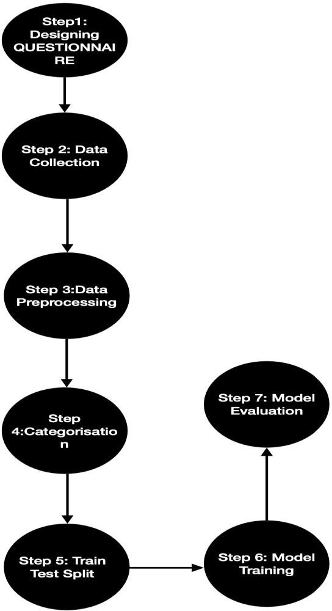

RESULTS AND ANALYSIS

Model Accuracy:- Overall we trained three models where we also evaluated the findings from all the three models with the intent to find the best model which can effectively predict the Gen-Z spending types effectively, the results are as follows:-

Table 4.1: Accuracy Table

Logistic Regression | Accuracy=70%
Decision Tree | Accuracy=96%
Random Forest | Accuracy=97%

- The first model that was trained and checked for accuracy was logistic regression, which gave the least number in terms of accuracy, because of the basic fundamental of logistic regression that is logistic regression assumes the data is linear, whereas our project is built on spending pattern which is not linear and it has many influential factors that varies from person to person, so it’s a complex topic and logistic regression cant handle complexity very well.

- Decision tree was the second model to be trained and it actually performed well with respect to our topic, the reason being decision tree works with variables or data splitting them into branches like for example we could say it splits data into conditions which is or can be closely related to the project, like if you have selected this option you are probably an impulsive spender if we consider our project or else you are a frugal spender thats what is roughly done in our interest of things, the point where decision tree is not so useful is it learns it will consider only one single question from the questionnaire and looks for answers like a respondent has chosen the first option and is a saver, also we have many such instances where its the same so probably that’s how it goes, so it has learned from data, now if considering another question from the questionnaire and work with both the questions we will fluctuations in data are observed that is out of 100 people who has selected the first option 60 our planner savers now because we are considering the second question as well so now our model will get stuck because it only works with a single point of view.

- The last and the most successful model was the random forest classifier which showed the best accuracy of 97%, because if we monitor things random forest works like the decision tree but with only one thing that stands out while with respect to the decision tree that it predicts output using multiple decision trees that is it can work with more than one condition at a time, with random subsets of data where Q6 and Q12 can both have different options selected still with the same spending category which just solves our problem of the decision tree as it can consider several outputs at once and hence can consider distinct options and predict the output without getting stuck like the decision tree

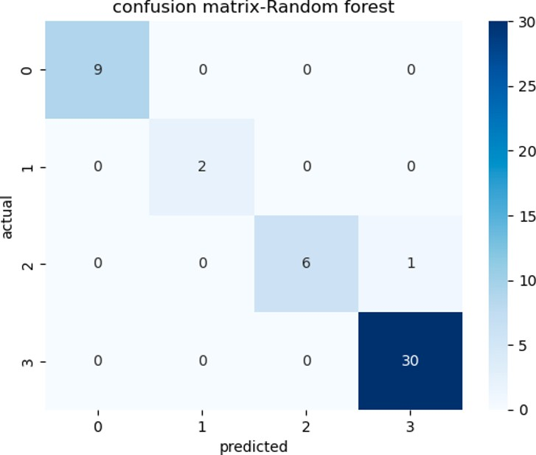

Figure4.1

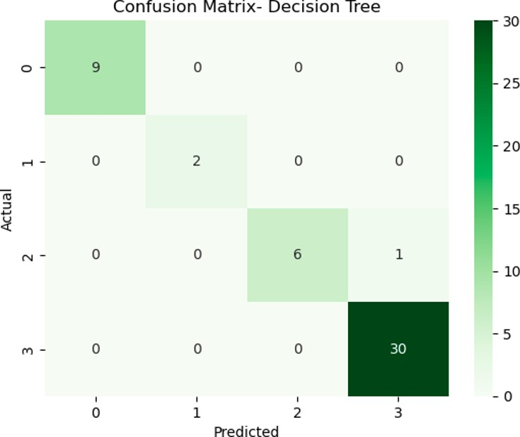

Figure4.2

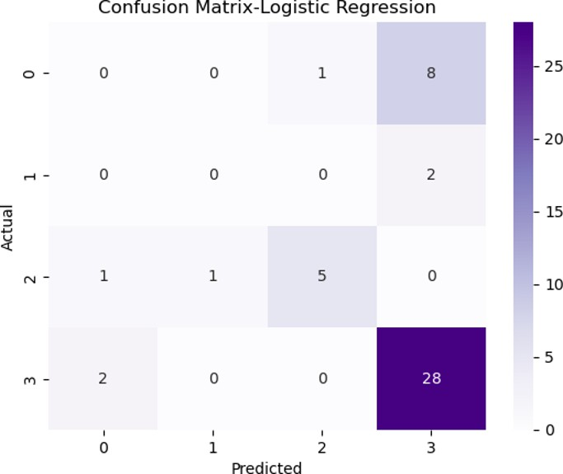

Figure 4.3

With respect to our confusion matrices, we analysed that the confusion matrix for random forest and the decision tree is roughly the same with their accuracy being very close to each other but decision tree being very prone to overfitting , random forest gets the upper hand 90% of the time as the decision tree splits the data until it perfectly balances with the training data and thinks about in a single way generalising the similar options selected whereas random forest works on multiple decision trees so even if one tree doesn’t clearly classify the spenders, the other tree corrects it making it more reliable, like for example if 8 out of 10 trees classify a spender as Impulsive and only 2 classify it as balanced, the random forest model gives out result as impulsive as it works on majority formula, making it more reliable with more trees working on the same dataset but with different approach signalling high accuracy at its definition.

Insights:- We divided the spenders into 4 dominant types based on the options selected, where we observed that most number of spenders fall under the planner/saver category while showing few outliers that were recorded in the the rest 3 spender types that is being Impulsive, Balanced, Frugal etc, being precise we saw almost 70% of the crowd from the small sample we took fall under the saver category, which suggests awareness amongst the youth of our country that they are aware of the future spendings and spend accordingly now, as very few people fall under the impulsive and frugal category, we see a trend in todays individual about awareness to save and financial literacy being at its peak contrary to what the millennial trend was.

Health is wealth:- As observed while asking about the spending preferences about the Gen-Z, a noticeable and insightful thing was people prioritised spending on themselves, on their health more than spending on entertainment, parties other social spendings etc, as today’s generation considers going to the gym, yoga or sports as a priority rather than a liability, money transfer or focus shifts towards the health industry has increased significantly over the past 15 years as it has influenced a lot of people who are adults or in their mid 20’s to take up fitness as a goal going hand in hand shaping both their careers and body rather than a separate wish to field to look upon.

Rise of digital payments and peer influence:- Also the project focuses on the hold of digital payments, online payments over liquid cash which has been experienced by the Gen-Z on a much greater scale than the millennials, though the millennials were the first one to experience this trend shift still the Gen-Z grew with the shift as they were more prone to digital payments and online modes of money transfer when they became adults and started paying by themselves, as with the influence of India’s own UPI, and also the innovations like Google Pay and Phone Pay coming into picture, also a thing coming with innovations is social influence or prioritising things which are
prioritised by others due to the uneven social and financial condition of all the 254 people that were taken for the task in hand, it was seen that both of these things influenced individuals with their spendings but self awareness was stronger in taking them to the Planner category, with people thinking more about the upcoming tasks while the current picture in their mind.

Overfitting check:- The most dominant model out of the three was random forest classifier, but it also hinted a possible over fitting scenario which was due to our small dataset of only 254 respondents, later we tries 5 random splits on data to validate whether if it is learning from data, and it shows consistency in results in all random splits of data as it shows over 90% accuracy each split

Table 4.2: 5 Random Splits

Split 1 | Split 2 | Split 3 | Split 4 | Split 5
96 | 92 | 98 | 94 | 98

So as visually seen in the table the random forest is giving stable accuracy checks in every random split we train the dataset by, since the dataset is small it could’ve shown high variance in data when we train the model randomly for 5 times but that symptom was not seen in the training shuffles that was executed, so basically which gives us the feeling that the random forest is performing very well as it is not learning from data but predicting the values well after every random split, so RANDOM FOREST can be labelled as the best model with. Respect to the results and accuracy that is shown through random splits it has gone through.

Table 4.3: Other Performance Metrics for Random Forest Classifier

Precision | Recall | F1 score | Support
1.00 | 1.00 | 1.00 | 9
1.00 | 1.00 | 1.00 | 2
1.00 | 0.86 | 0.92 | 7
0.97 | 1.00 | 98 | 30
All with respect to each spending types like Balanced, Frugal, Impulsive, Planner/Saver

One more thing that was worth considering was the age gap between the spenders and how that would affect the analysis like the project generalised the Gen-Z from the age of 18 and 25 that is the people who were born from 2000 to 2007 just to carry out the smooth flow of answers and reaching out to maximum people, but those 7 years that are considered in our survey are the years where an
individual goes through a lot of changes in their life and spending habits is one of the severe things in this aspect, if looked upon carefully one important insight was to look for the age group of every particular respondent and categorise people with that so as to discover new findings and traits of people in a particular age group. Keeping in mind all this one plot displayed in the project takes us to the information of our interest regarding the age groups of spenders.

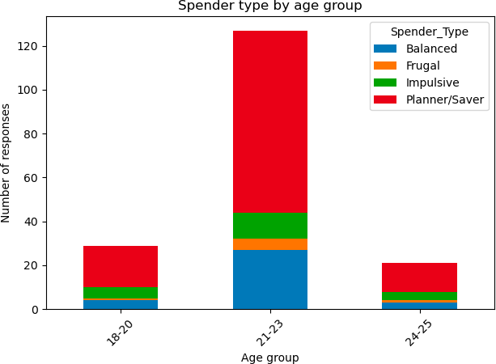

Figure 4.4
As visible in the graph it aimed at deriving customers into three age categories noticeably people from the age group 18-20, 21-23, 24-25 significantly only because the first criteria is where students are undergoing their basic bachelor education with just new hands on with bank accounts, pocket money, educational spendings travelling expenses etc. Second age category are the people who are now established adults they’re in their 20’s and now comfortable with spendings with a basic aim in mind for the next 4/5 years the third and the last category is where people are just settling in their lives taking up the family responsibilities probably paying an EMI or giving home some money for the basic homely expenses, contrast to what the people of age 18 wouldn’t do so it was important to categorise the respondents and see their mindset, and as derived we could see that the majority in
each age group belong to the planner saver category which is a very easeful sign because it just
reflects that the young teens also know or have the importance of a well structured plan for
spendings and savings as 70% of the population in each category belong to the planner/saver category which shows stable results and help in model prediction with very less fluctuation in data As very few to no outliers are seen in our dataset of 254 respondents.

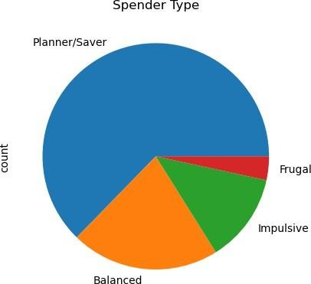
Figure 4.5

- One more visualisation of how our outcomes are spread from the data we extracted from google forms with nearly 70% people labelled as Planner/Saver
- At number 2 the people who belong to the balanced category show typically both the traits but are labelled as balanced due to their more dynamic spending decisions than where our majority lies
- Impulsive spenders are placed at number 3 with respect to number of people as they are the spenders who like to spend more, if we have to define them properly they are the people who rank their wants higher than their needs, like they’ll want to buy the new iPhone every year or alternate years even if the existing device is working perfectly fine. They value their STATUS more than their basic needs.
- Least number of people are categorised as Frugal spenders, these are not the spenders who cant
spend on a particular entity but these are the spenders who don’t want to spend, closely linked
with the savers category, frugal spenders are very less in number because spenders tend to spend on liabilities as well but keeping in mind the further expenses, so we can include frugal spenders in the saver category but we can’t include the planners in frugal as the spendings towards wants would be less but they still have an existence.

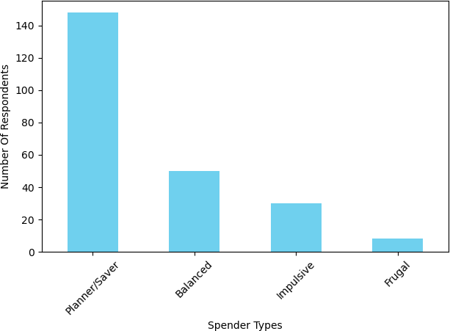

Figure 4.6

DISCUSSION

Primary Spending:

What the results interpret are a quick shift between generations with respect to the spending priorities and financial literacy which is also due to the dynamic lifestyle this generation is going through on a day to day basis, such as the trend changes be it clothing, cars or similar other lifestyle traits. Also the changes happening in the modern world, as majority of people focusing more towards health & wellness, lifestyle & self-care which was not a thing worth considering for the early millennials when they were in the age most of the Gen-Z people are, which gives us a clear indication of the modern generation leaning more towards the dynamic gym culture as the thing which every person from the age 18-25 or from the later teens to the mature adults focuses more on in the present day, additionally we notice that with the health and wellness being the most basic and fundamental aspect of the current generation’s spending priority, lifestyle and self-care have eventually been termed as the second most prioritised spending. Later on the study also focused on some different perspective where responders were also asked about a scenario where if they receive additional benefits from their parents, work what would be their spending priority, and then we saw noticeable changes in various spenders with their choices, saying this, still people emphasised more on health and wellness as their primary goal, but various secondary factors also came into picture like savings, social spendings, transportation etc which all inclusive shows a positive outcome with respect to financial literacy in the current young individuals and can be stated as a sign worth emphasising on for an individual in shaping their future, family, life.

Peer Influence & Savings:
One of the primary factor in the survey was also peer influence that is influence by some external factor which shapes a persons expenditure either positively or negatively based on the personal mindset and can be a very good criteria in order to examine financial literacy in the long run. Mixed observations were recorded in the survey with probably no option which could have been termed as the most opted answer, but the positive side of things still being that 60-70% answers were probably not buy it or wait for the price drop of a certain product which shows financial awareness between respondents and also boosts financial literacy, though peer influence on a whole has gradually increased in the Gen-Z due to the increase of resources where luxurious, semi-luxurious things are exposed to the middle class as well, which holds typically 70/80% of the total population of our country which was not the case similar to what the old people said in the 80’,or 90’s because of less exposure to technology and also the needs of people were quite basic which categorised people in a more easier way.
Usually the easiest way to arrange money when you are in an emergency situation or due to some non-negotiable expenditure, is by using your SAVINGS, these days savings and its importance has increased with no proper definition assigned to it as it is an interchangeable constant with money making, suppose you have decided to engage in a saving of 2000 rupees per month, probably a bank scheme where you receive amount + interest after probably a year, there may be two options of how you may go with things one aspect could be try increasing your income which would be difficult at an age where you are financially dependent on your parents for money, and the second alternative maybe adjust using your savings every month which would be easier as compared to the previous alternative so having a positive approach towards savings from a young age is a very positive sign towards financial literacy and our results have shown things which are quite similar to preferable norms of good financial literacy as responses have shown a leap in positive responses when conditions have given them a liability of having some extra penny each month, which drills focus towards savings wherever necessary and not showcase a lifestyle where extra money= extra social spendings or lifestyle expenses.
Previous studies have also focused on these important factors such as financial literacy, peer influence, digital payments that defines a persons spendings but none have used the variables to tell you some extra insight about the spenders using these variables as such, so our study effectively describes the person as a respective spender type with respect to the way a spender goes about things or with respect to the answers that were reported through our questionnaire.

LIMITATION:

- These responses were recorded with a small sample size of 254 respondents, from approximately a very similar background and similar perspective which could ultimately give
us an idea that this might not be the standard opinion of every teen/Gen-Z in the country or there might be room for more research in the current subject moving on.
- Questionnaire that was built in order to examine the respondents was observed to have things which may seem interesting to a certain part of the society that is people from the semi-urban to urban places, people who have very less or no exposure to providing things to their family, also it has no exposure to people who have the liability to not think about the spendings at all , so ultimately the questionnaire talks about the people from the immediate network of the author
and also shows the authors background as such, which ultimately again takes us to the view that this might not fully correlate with every person in our age criteria as such.
- Our most dominant model the random forest classifier with an accuracy of 97% with respect to predicting the spender type of an individual may be termed as overfitting due to its small
sample size and lack of data collection on a larger scale, though the overfitting check was one positive aspect as it turned out to be in our favour, but this overfitting can still be an issue with our research as going with the norms, proper research requires thousands of records and can still have scope for improvement.

CONCLUSION:

This project aimed and worked towards analysing the Gen-Z with their spendings through a questionnaire with the help of GOOGLE FORMS, later segregating the spendings into distinct spender types with respect to the answer opted in the questionnaire, the projects main focus was to learn the financial behaviour, the financial awareness of the students/people that fall in the age group of 18-25 as these are the bunch of people who were born or basically brought up when technology started rising, and now that technology and innovation are at a peak these people have also entered their peak period of young adults where each distinct individual goes through or is currently going through changes whether in their their choices, interests, spendings etc. We successfully collected data from 254 respondents who included our close descendants, mutual friends or the people who generally find themselves in the same vicinity. We tested the respondents with 17 questions which included various personal life questions and questions where their financial stability will be tested, though we categorised the spenders with only 3 questions which tested their financial awareness, financial literacy, spending priorities and hence later categorised them. Out of all the respondents almost 70% to be precise are successfully categorised as Planner/Saver, which showed signs of the youth being very mindful of their spendings which certainly can be a thing to
admire in near future. Still, we had more 3 spending types that also had some spenders Balanced , Impulsive and frugal ranked with respect to the order they are mentioned. Which certainly was convincing to mention todays youth are cautious as well as mindful of their spending and can be counted as the most useful insight of our study. Later it was also noticed that Health and wellness, Lifestyle and self-care turned out to be the most prioritised spendings reflecting social influence and the leap of the gym culture in the young adults as compared to the previous generation, showing the trends that change within generations. Technically we implemented machine learning to predict the spender types with the train-test split where we noticed the random forest classifier to be the best model of the all that showed the most promising accuracy rate of 97%, with this high accuracy rate there is always chances of overfitting which was also tested when attempts were made to split the data in to 5 random splits and then the results generated gave a clear idea that the model didn’t overfit or learn from the data as we had scores of 90+ each time but it showed variance, which answered a question that if the study is to be looked upon in future, the random forest classifier should be the most simple and promising choice as the respondents answers can vary and have outliers which can help the random forest to be well aligned to the study and use multiple decision trees on top that are beneficial to counter various trends in a single algorithm as such,
providing strength to our study and making it easy for us to categorise spenders in a more complex way that can show much more non-linearity than our project

FUTURE-WORK
Though the project was successful, and gave us clear insights about the Gen-Z spending pattern there’s still some room for deeper analysis and hence this section is very important, stating the future work that can be added on top of this or our study can be useful in trying to build the foundation or expectations of a new research, we can either add more number of students from the same vicinity to strengthen our study, or add students from different backgrounds with different
financial backgrounds or family status to boost data variance which would sharpen the study, Also, we could add more variables to study the spending patterns and consider this a generic mid-level study to build more advanced studies on. Concluding, it could be termed as this study of Gen-Z or spendings of the Gen-Z will always be a topic of research in the age of growing technology,
lifestyle and the dynamic behaviour of each person growing up as adults.

References:

- Bhatia, R., & Shete, V. USAGE OF UPI TRANSACTION AND ITS CHALLENGES-A STUDY ON GENZ AND MILLENIALS.

- Mishra, S., & Rajora, V. (2018). A study on Digital Payment System with special reference to Youth. International Journal of Creative Research Thoughts (IJCRT), 237-242.

- Kumar, A., Choudhary, R. K., Mishra, S. K., Kar, S. K., & Bansal, R. (2022). The growth trajectory of UPI-based mobile payments in India: Enablers and inhibitors. Indian Journal of Finance and Banking, 11(1), 45-59.

- Pandya, M. J. D. (2023). A Study on Financial Literacy among Millennials & GenZ
DJournal. https://ij. darshan. ac. in/DIJCM/Past-Issues.

- Mardosaite, V., Jasinskas, E., & Romeika, G. (2024). The transformation of digital innovative services in retail trade due to the COVID-19 pandemic: A systematic review. Amfiteatru economic, 26(67), 885-902.

- Dev, H., Gupta, R., Dharmavaram, S., & Kumar, D. (2024). From Cash to Cashless: UPI's Impact on Spending Behavior Among Indian Users and Prototyping Financially Responsible Interfaces. arXiv preprint arXiv:2401.09937.

- Invalli, S. (2025). Digital Payment Patterns in India: A Cross-Sectional Study of Credit Cards, Debit Cards, and Unified Payments Interface (UPI) Trends. Cureus Journals, 2(1).

- Gebeyehu, F., & Mavridis, A. (2023). Buy Now, Pay Later: Assessing the Financial and Behavioral Implications for Gen-Z Consumers in the USA.

- Chindemi, G. (2022). Generation Z and financial literacy in Japan: A preliminary

discourse on attitudes, behavior, and outlook. Chugokugakuen Journal, 21, 9-15

- Nanda, M. C. (2020). Gen-Z shopping: Separating myth from reality Business of Fashion

